**MESH 1**

/* -*- Mode:C++; c-file-style:"gnu"; indent-tabs-mode:nil; -*- */

/*

* Copyright (c) 2008,2009 IITP RAS

*

* This program is free software; you can redistribute it and/or modify

* it under the terms of the GNU General Public License version 2 as

* published by the Free Software Foundation;

*

* This program is distributed in the hope that it will be useful,

* but WITHOUT ANY WARRANTY; without even the implied warranty of

* MERCHANTABILITY or FITNESS FOR A PARTICULAR PURPOSE. See the

* GNU General Public License for more details.

*

* You should have received a copy of the GNU General Public License

* along with this program; if not, write to the Free Software

* Foundation, Inc., 59 Temple Place, Suite 330, Boston, MA 02111-1307 USA

*

* Author: Kirill Andreev <andreev@iitp.ru>

*

*

* By default this script creates m_xSize * m_ySize square grid topology with

* IEEE802.11s stack installed at each node with peering management

* and HWMP protocol.

* The side of the square cell is defined by m_step parameter.

* When topology is created, UDP ping is installed to opposite corners

* by diagonals. packet size of the UDP ping and interval between two

* successive packets is configurable.

*

* m_xSize * step

* |<--------->|

* step

* |<--->|

* * --- * --- * <---Ping sink _

* | \ | / | ^

* | \ | / | |

* * --- * --- * m_ySize * step |

* | / | \ | |

* | / | \ | |

* * --- * --- * _

* ^ Ping source

*

* See also MeshTest::Configure to read more about configurable

* parameters.

*/

#include "ns3/core-module.h"

#include "ns3/internet-module.h"

#include "ns3/network-module.h"

#include "ns3/applications-module.h"

#include "ns3/wifi-module.h"

#include "ns3/mesh-module.h"

#include "ns3/mobility-module.h"

#include "ns3/mesh-helper.h"

#include <iostream>

#include <sstream>

#include <fstream>

using namespace ns3;

NS_LOG_COMPONENT_DEFINE ("TestMeshScript");

class MeshTest

{

public:

MeshTest ();

void Configure (int argc, char ** argv);

int Run ();

private:

int m_xSize;

int m_ySize;

double m_step;

double m_randomStart;

double m_totalTime;

double m_packetInterval;

uint16_t m_packetSize;

uint32_t m_nIfaces;

bool m_chan;

bool m_pcap;

std::string m_stack;

std::string m_root;

NodeContainer nodes;

NetDeviceContainer meshDevices;

// Addresses of interfaces:

Ipv4InterfaceContainer interfaces;

// MeshHelper. Report is not static methods

MeshHelper mesh;

private:

void CreateNodes ();

void InstallInternetStack ();

void InstallApplication ();

void Report ();

};

MeshTest::MeshTest () :

m_xSize (3),

m_ySize (3),

m_step (100.0),

m_randomStart (0.1),

m_totalTime (100.0),

m_packetInterval (0.1),

m_packetSize (1024),

m_nIfaces (1),

m_chan (true),

m_pcap (false),

m_stack ("ns3::Dot11sStack"),

m_root ("ff:ff:ff:ff:ff:ff")

{

}

void

MeshTest::Configure (int argc, char *argv[])

{

CommandLine cmd;

cmd.AddValue ("x-size", "Number of nodes in a row grid. [6]", m_xSize);

cmd.AddValue ("y-size", "Number of rows in a grid. [6]", m_ySize);

cmd.AddValue ("step", "Size of edge in our grid, meters. [100 m]", m_step);

/*

* As soon as starting node means that it sends a beacon,

* simultaneous start is not good.

*/

cmd.AddValue ("start", "Maximum random start delay, seconds. [0.1 s]", m_randomStart);

cmd.AddValue ("time", "Simulation time, seconds [100 s]", m_totalTime);

cmd.AddValue ("packet-interval", "Interval between packets in UDP ping, seconds [0.001 s]", m_packetInterval);

cmd.AddValue ("packet-size", "Size of packets in UDP ping", m_packetSize);

cmd.AddValue ("interfaces", "Number of radio interfaces used by each mesh point. [1]", m_nIfaces);

cmd.AddValue ("channels", "Use different frequency channels for different interfaces. [0]", m_chan);

cmd.AddValue ("pcap", "Enable PCAP traces on interfaces. [0]", m_pcap);

cmd.AddValue ("stack", "Type of protocol stack. ns3::Dot11sStack by default", m_stack);

cmd.AddValue ("root", "Mac address of root mesh point in HWMP", m_root);

cmd.Parse (argc, argv);

NS_LOG_DEBUG ("Grid:" << m_xSize << "*" << m_ySize);

NS_LOG_DEBUG ("Simulation time: " << m_totalTime << " s");

}

void

MeshTest::CreateNodes ()

{

/*

* Create m_ySize*m_xSize stations to form a grid topology

*/

nodes.Create (m_ySize*m_xSize);

// Configure YansWifiChannel

YansWifiPhyHelper wifiPhy = YansWifiPhyHelper::Default ();

YansWifiChannelHelper wifiChannel = YansWifiChannelHelper::Default ();

wifiPhy.SetChannel (wifiChannel.Create ());

/*

* Create mesh helper and set stack installer to it

* Stack installer creates all needed protocols and installs them to

* mesh point device

*/

mesh = MeshHelper::Default ();

if (!Mac48Address (m_root.c_str ()).IsBroadcast ())

{

mesh.SetStackInstaller (m_stack, "Root", Mac48AddressValue (Mac48Address (m_root.c_str ())));

}

else

{

// If root is not set, we do not use "Root" attribute, because it

// is specified only for 11s

mesh.SetStackInstaller (m_stack);

}

if (m_chan)

{

mesh.SetSpreadInterfaceChannels (MeshHelper::SPREAD_CHANNELS);

}

else

{

mesh.SetSpreadInterfaceChannels (MeshHelper::ZERO_CHANNEL);

}

mesh.SetMacType ("RandomStart", TimeValue (Seconds (m_randomStart)));

// Set number of interfaces - default is single-interface mesh point

mesh.SetNumberOfInterfaces (m_nIfaces);

// Install protocols and return container with MeshPointDevices

meshDevices = mesh.Install (wifiPhy, nodes);

// Setup mobility - static grid topology

MobilityHelper mobility;

mobility.SetPositionAllocator ("ns3::GridPositionAllocator",

"MinX", DoubleValue (0.0),

"MinY", DoubleValue (0.0),

"DeltaX", DoubleValue (m_step),

"DeltaY", DoubleValue (m_step),

"GridWidth", UintegerValue (m_xSize),

"LayoutType", StringValue ("RowFirst"));

mobility.SetMobilityModel ("ns3::ConstantPositionMobilityModel");

mobility.Install (nodes);

if (m_pcap)

{

wifiPhy.EnablePcapAll (std::string ("mp-"));

}

}

void

MeshTest::InstallInternetStack ()

{

InternetStackHelper internetStack;

internetStack.Install (nodes);

Ipv4AddressHelper address;

address.SetBase ("10.1.1.0", "255.255.255.0");

interfaces = address.Assign (meshDevices);

}

void

MeshTest::InstallApplication ()

{

// UdpEchoServerHelper echoServer (9);

// ApplicationContainer serverApps = echoServer.Install (nodes.Get (0));

// serverApps.Start (Seconds (0.0));

// serverApps.Stop (Seconds (m_totalTime));

// UdpEchoClientHelper echoClient (interfaces.GetAddress (0), 9);

// echoClient.SetAttribute ("MaxPackets", UintegerValue ((uint32_t)(m_totalTime*(1/m_packetInterval))));

// echoClient.SetAttribute ("Interval", TimeValue (Seconds (m_packetInterval)));

// echoClient.SetAttribute ("PacketSize", UintegerValue (m_packetSize));

// ApplicationContainer clientApps = echoClient.Install (nodes.Get (m_xSize * m_ySize - 1));

// clientApps.Start (Seconds (0.0));

// clientApps.Stop (Seconds (m_totalTime));

UdpEchoServerHelper echoServer (9);

ApplicationContainer serverApps = echoServer.Install (nodes.Get (1));

serverApps.Start (Seconds (1.0));

serverApps.Stop (Seconds (10.0));

UdpEchoClientHelper echoClient (Ipv4Address ("10.1.1.2"), 9);

echoClient.SetAttribute ("MaxPackets", UintegerValue (1));

echoClient.SetAttribute ("Interval", TimeValue (Seconds (1.0)));

echoClient.SetAttribute ("PacketSize", UintegerValue (1024));

ApplicationContainer clientApps = echoClient.Install (nodes.Get (0));

clientApps.Start (Seconds (2.0));

clientApps.Stop (Seconds (10.0));

}

int

MeshTest::Run ()

{

CreateNodes ();

InstallInternetStack ();

InstallApplication ();

Simulator::Schedule (Seconds (m_totalTime), &MeshTest::Report, this);

Simulator::Stop (Seconds (m_totalTime));

Simulator::Run ();

Simulator::Destroy ();

return 0;

}

void

MeshTest::Report ()

{

unsigned n (0);

for (NetDeviceContainer::Iterator i = meshDevices.Begin (); i != meshDevices.End (); ++i, ++n)

{

std::ostringstream os;

os << "mp-report-" << n << ".xml";

std::cerr << "Printing mesh point device #" << n << " diagnostics to " << os.str () << "\n";

std::ofstream of;

of.open (os.str ().c_str ());

if (!of.is_open ())

{

std::cerr << "Error: Can't open file " << os.str () << "\n";

return;

}

mesh.Report (*i, of);

of.close ();

}

}

int

main (int argc, char *argv[])

{

MeshTest t;

t.Configure (argc, argv);

return t.Run ();

}

OUTPUT

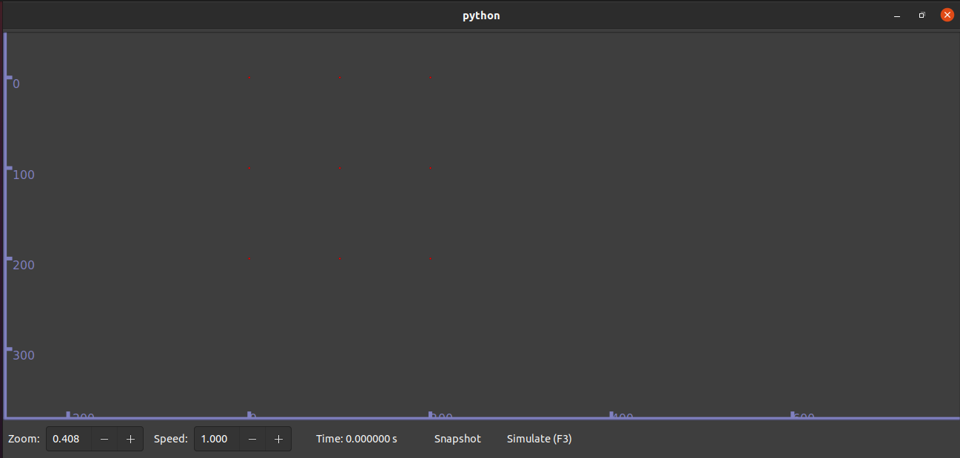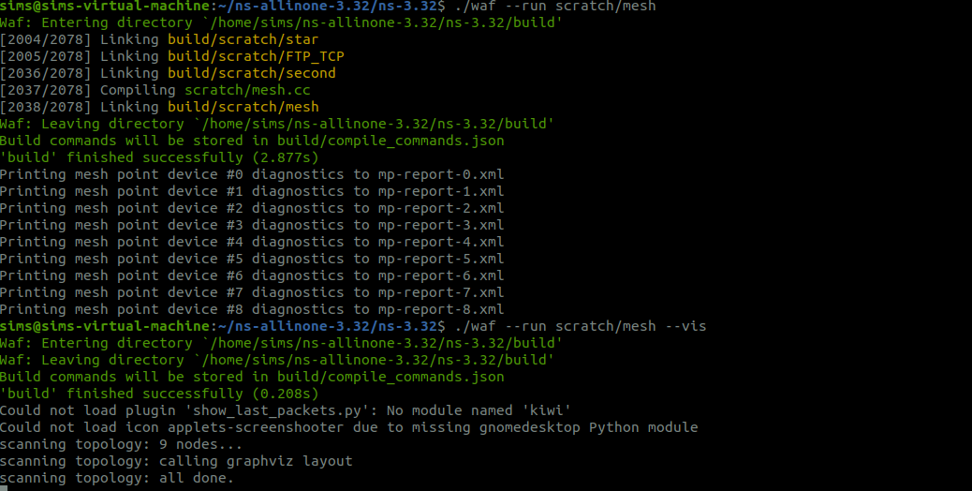

**MESH 2**

#include "ns3/core-module.h"

#include "ns3/network-module.h"

#include "ns3/internet-module.h"

#include "ns3/mobility-module.h"

#include "ns3/wifi-module.h"

#include "ns3/applications-module.h"

#include "ns3/mesh-module.h"

using namespace ns3;

NS_LOG_COMPONENT_DEFINE ("MeshExample");

int main(int argc, char *argv[])

{

// Enable logging

LogComponentEnable("MeshExample", LOG_LEVEL_INFO);

LogComponentEnable("UdpEchoClientApplication", LOG_LEVEL_INFO);

LogComponentEnable("UdpEchoServerApplication", LOG_LEVEL_INFO);

LogComponentEnable("WifiMac", LOG_LEVEL_INFO);

// Set up command line arguments

CommandLine cmd;

cmd.Parse(argc, argv);

// Create 4 nodes for the mesh network

NodeContainer nodes;

nodes.Create(4);

// Set up Wi-Fi devices (mesh network)

WifiMacHelper wifiMac;

wifiMac.SetType("ns3::AdhocWifiMac");

WifiHelper wifi;

wifi.SetRemoteStationManager("ns3::AarfWifiManager");

YansWifiPhyHelper wifiPhy = YansWifiPhyHelper::Default();

YansWifiChannelHelper wifiChannel = YansWifiChannelHelper::Default();

wifiPhy.SetChannel(wifiChannel.Create());

NetDeviceContainer devices = wifi.Install(wifiPhy, wifiMac, nodes);

// Set up Mobility Model

MobilityHelper mobility;

// Use ConstantPositionMobilityModel to avoid freezing

mobility.SetMobilityModel("ns3::ConstantPositionMobilityModel");

// Simple position allocator - placing nodes in a grid

Ptr<ListPositionAllocator> positionAlloc = CreateObject<ListPositionAllocator>();

positionAlloc->Add(Vector(10.0, 10.0, 0.0));

positionAlloc->Add(Vector(20.0, 10.0, 0.0));

positionAlloc->Add(Vector(10.0, 20.0, 0.0));

positionAlloc->Add(Vector(20.0, 20.0, 0.0));

mobility.SetPositionAllocator(positionAlloc);

mobility.Install(nodes);

// Install Internet stack

InternetStackHelper stack;

stack.Install(nodes);

// Set up IP addresses for nodes

Ipv4AddressHelper address;

address.SetBase("10.1.1.0", "255.255.255.0");

Ipv4InterfaceContainer interfaces = address.Assign(devices);

// Create and install the UDP server application on node 1 (server)

UdpEchoServerHelper echoServer(9);

ApplicationContainer serverApps = echoServer.Install(nodes.Get(1)); // Server on node 1

serverApps.Start(Seconds(1.0));

serverApps.Stop(Seconds(10.0));

// Create and install the UDP client application on node 0 (client)

UdpEchoClientHelper echoClient(interfaces.GetAddress(1), 9);

echoClient.SetAttribute("MaxPackets", UintegerValue(10));

echoClient.SetAttribute("Interval", TimeValue(Seconds(1.0)));

echoClient.SetAttribute("PacketSize", UintegerValue(1024));

ApplicationContainer clientApps = echoClient.Install(nodes.Get(0)); // Client on node 0

clientApps.Start(Seconds(2.0));

clientApps.Stop(Seconds(10.0));

// Run the simulation

Simulator::Run();

Simulator::Destroy();

return 0;

}

OUTPUT

